Understanding Revelation: Intro
I wanted to get the Isaiah chapters from the Book of Mormon out first before I went into Daniel, Revelation, Joel, Ezekiel, Malachi etc. Now that I have done that I feel like this is a good time to understand the Book of Revelation, Daniel, etc but before one begins reading my understanding of these things one must understand how I prioritize revelation from heaven, how I view doctrine. The way I dissect truth personally (as well as how I feel all the children of light should dissect truth) is:
1. Words from Jesus spoken to an individual in the flesh (you need to be careful with this because Satan can appear as an angel of light, you need to know how to discern spirits)
2. Concrete words of the prophet Joseph Smith (or the prophet of your dispensation)
3. The standard works, identified by the head of your dispensation, with greater priority to the Book of Mormon and Doctrine and Covenants (scripture written specifically for your dispensation)
4. Concrete words from prophets and apostles who surrounded Joseph Smith (the head of your dispensation)
5. Modern prophets and apostles
I do not accept anything written by “scholars” (a fancy word for somebody who has no keys, I could call myself a scholar, it doesn’t mean anything) unless it is obviously backed up with other concrete sources listed above. Procedure changes, doctrine does not. For example, at one point in time only the Levites could hold certain priesthoods, at certain times only the Jews could hold certain priesthoods, at certain times descendants of Ham and thus Cain were denied the privilege of holding the priesthood- this is all procedure, they change as times, people and circumstances change in God’s kingdom. Doctrine however does not change. The doctrine in that situation would be the why. Why were Levites given certain priesthood and others denied? Why were the Jews given certain priesthoods and others denied? Why were the descendants of Ham and thus Cain denied certain priesthoods? We have dozens and dozens of concrete teachings and doctrine from the prophet Joseph Smith, Brigham Young, the Pratts, (as well as the Book of Mormon) etc explaining the “why” crystal clear the doctrine never changes and we know that doctrine will never change. It doesn’t matter if the prophet of God on the earth who holds the keys at that time says “it isn’t so”, the keys of the kingdom that the prophet holds does not give him the right, privilege, honor to change doctrine, only to reveal new, additional doctrine and change procedure. New doctrine cannot conflict with old doctrine, it can only add to it, clarify, shed further light etc. Seeing as though Jesus doesn’t make it a habit of appearing to all of his members in the flesh frequently, his way is to make his will known to us through his revealer in this last dispensation, Joseph Smith. There is a hierarchy of truth. Jesus sits on the top of this hierarchy and directly underneath him is the prophet of your dispensation (Noah, Abraham, Peter, Joseph etc). So for example, if Peter said “you need to do 10 jumping jacks to be saved in the kingdom of God” and Paul came out and said “you don’t need to do 10 jumping jacks to be saved in the kingdom of God,” or “you need to do 8 jumping jacks” or “we don’t know why we are doing jumping jacks” even though Paul is a great man, even though he has some keys, his right to doctrine is superseded by that of Peter in that dispensation. We, unlike the Muslims, Catholics etc, DO NOT believe in abrogation or supersessionism etc. As soon as you say that Noah, Peter, Joseph Smith, etc during their dispensation that they could have been wrong on any revealed doctrine it opens the flood gates of doubt and Satan’s influence and allows everything said by them to be re-evaluated. This is one of the oldest and ugliest tricks of Satan. With that said, if I have concrete evidence of doctrine taught by Joseph Smith, I don’t care how wise of a scholar another person is, if they teach something contrary to what Joseph Smith taught, I stick with Joseph Smith, until the only thing that can actually supersede him tells me otherwise (that would be Jesus).
With that said, what is the most important thing that Joseph Smith taught with respect to the book of Revelation? “Now, I make this declaration, that those things which John saw in heaven had no allusion to anything that had been on the earth previous to that time, because they were the representation of ‘things which must shortly come to pass,’ and not of what has already transpired. John saw beasts that had to do with things on the earth, but not in past ages. The beasts which John saw had to devour the inhabitants of the earth in days to come. ‘And I saw when the Lamb opened one of the seals; and I heard, as it were the noise of thunder, one of the four beasts saying, Come and see. And I saw, and beheld a white horse: and he that sat on him had a bow; and a crown was given unto him: and he went forth conquering, and to conquer. And when he had opened the second seal, I heard the second beast say, Come and see. And there went out another horse that was red: and power was given to him that sat thereon to take peace from the earth, and that they should kill one another; and there was given unto him a great sword.’ (Rev. 6:1,2,3,4) The book of Revelation is one of the plainest books God ever caused to be written. The revelations do not give us to understand anything of the past in relation to the kingdom of God” (Teachings of the Prophet Joseph Smith, p.290).
What Joseph Smith is clearly saying here is that John the Revelator did not see anything in past dispensations in this revelation. He only saw things pertaining to John’s time period forward. He then, to clear up any doubt of what he was referring to, proceeds to quote what John was shown directly after the first seal and second seal were opened and said that this book is the plainest book God has caused to be written. I have taken the quote directly how it appears in the TPJS book without editing it in the slightest or omitting anything, that is exactly how it appears and flows. So when you jump into studying the book of Revelation and you use modern scholars and even the Church’s current manual and you place the events that John described that he was shown directly after the first seal was open and you place these events in the time of Adam or the first 1000 years of earth’s temporal history, you are jumping into the book of Revelation, to understand it, with the assumption upfront that Joseph Smith was wrong. I do not make that assumption but rather the exact opposite, that Joseph Smith was correct and I can testify that when one has that understanding the book becomes a very plain book to understand.
New Testament Student Manual:
Revelation 1:1. The Book of Revelation Is an Unveiling
Gerald N. Lund, who later became a member of the Seventy, explained that the book of Revelation unveils many truths:
“The title of the book in Greek is Apocalypsis, from which we get its other common name, the Apocalypse. Apocalypsis is formed from two Greek words﻿—apo, a preposition denoting separation or removal, and kalypto, a verb meaning to cover, hide, or veil. Apocalypsis, then, literally means removal of the veil or covering. Hence its title in English, the book of Revelation (or the uncovering or unveiling).
“While many might find the title to be ironic, arguing that few books are more hidden or veiled, it is an appropriate one, for it truly reveals many things. Elder Bruce R. McConkie, in response to the question ‘Are we expected to understand the book of Revelation?’ answered:
“‘Certainly. Why else did the Lord reveal it? The common notion that it deals with beasts and plagues and mysterious symbolisms that cannot be understood is just not true. … If we apply ourselves with full purpose of heart, we can catch the vision of what the ancient Revelator recorded.’ (Ensign, Sept. 1975, 87.) …
“If we diligently use the keys that the Lord has given us to interpret the book of Revelation, it can truly become a book of revelation for us” (“Seeing the Book of Revelation as a Book of Revelation,” Ensign, Dec. 1987, 46, 52).
This is the first key that has been given to us that you need to understand to unlock the plainness of the book of Revelation- that it is all future from John’s time. Understanding this first key of insight gives us a second key of insight, namely when a seal was opened John was not shown the contents of the scroll but rather events that transpired on earth around the opening of that seal so that what John is shown as the seals are opened is the chronology of events in the last days leading up to the final seventh seal being opened and the ushering in of the Millennium and God’s Kingdom. Picture the scrolls as seven books and each book has a lock on the front, like a journal that has a lock.
Now picture seven of these side by side:
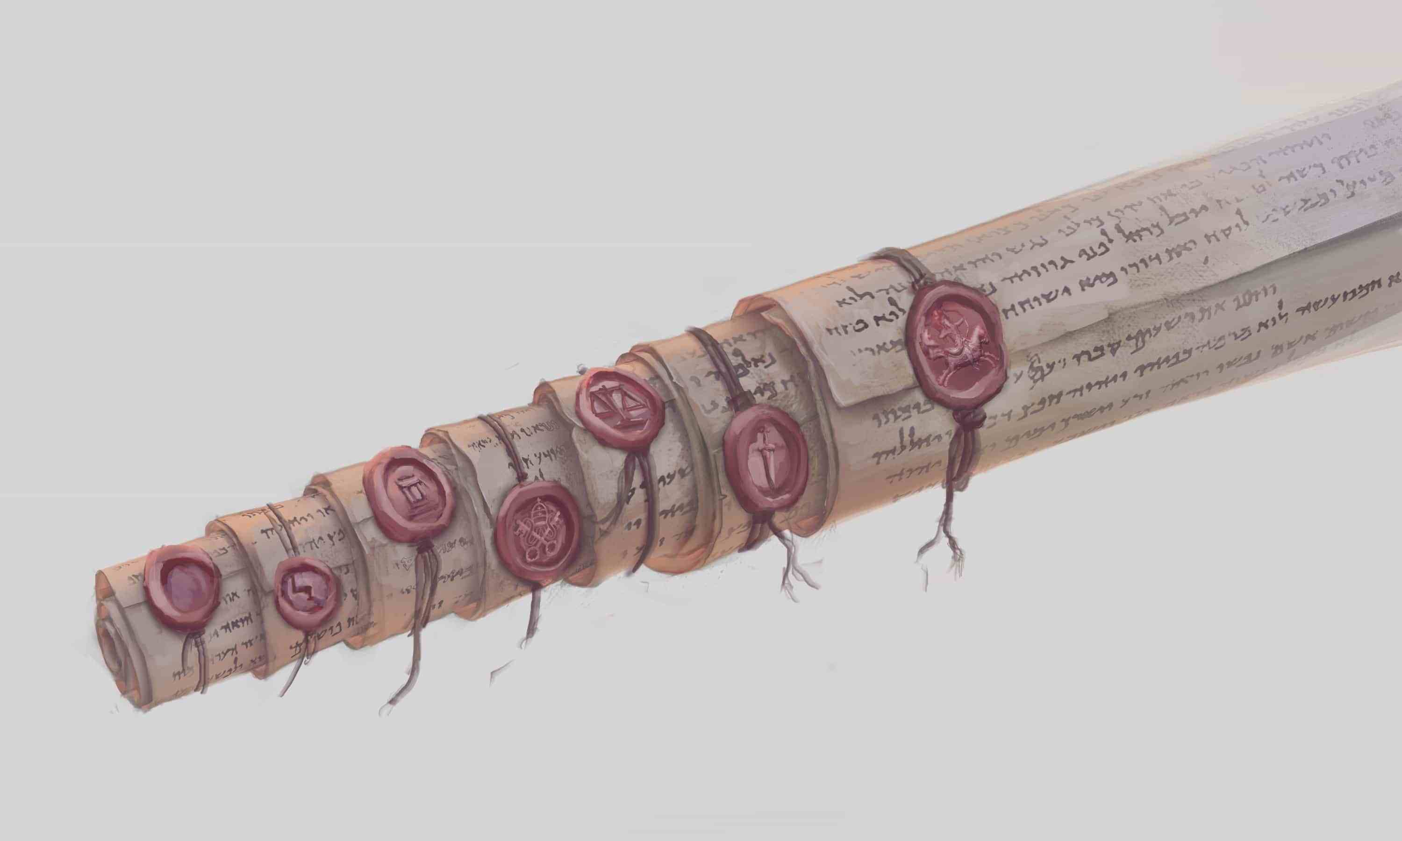
So John sees a seal broken; that would be like somebody sticking the key in the journal’s lock and then unlocking it. But the book doesn’t actually open. We are told that the first book contains things of the first 1000 years but what John is shown is not what is in the book but rather what happens around the time when the book is unlocked. So how do we know that John is not shown the contents of the book itself, other than the fact that Joseph taught us thus? What are the contents of the book?
D&C 77:6-7
6 Q. What are we to understand by the book which John saw, which was sealed on the back with seven seals?
A. We are to understand that it contains the revealed will, mysteries, and the works of God; the hidden things of his economy concerning this earth during the seven thousand years of its continuance, or its temporal existence.
7 Q. What are we to understand by the seven seals with which it was sealed?
A. We are to understand that the first seal contains the things of the first thousand years, and the second also of the second thousand years, and so on until the seventh.
We learn that very clearly in Doctrine and Covenants 88 when the contents of the scrolls are actually shown and read. In the subheading for verses 86-94 it explains “Signs, upheavals of the elements, and angels prepare the way for the coming of the Lord.” We learn in those verses of the sign of the Son of Man appearing in the sky, the seventh seal being opened, and there being silence in heaven for about the space of half an hour. Directly after that the next verses go over the judgments that are poured out on the world after the anointing, the resurrection of the just etc. Then we read in verses 108-110:
D&C 88:108-110
108 And then shall the first angel again sound his trump in the ears of all living, and reveal the secret acts of men, and the mighty works of God in the first thousand years.
109 And then shall the second angel sound his trump, and reveal the secret acts of men, and the thoughts and intents of their hearts, and the mighty works of God in the second thousand years—
110 And so on, until the seventh angel shall sound his trump; and he shall stand forth upon the land and upon the sea, and swear in the name of him who sitteth upon the throne, that there shall be time no longer; and Satan shall be bound, that old serpent, who is called the devil, and shall not be loosed for the space of a thousand years.
We learn that the contents of these scrolls, these books, contain the secret acts, works, of everyone born during each thousand years of earth’s temporal history. We know “that out of the books that shall be written shall men be judged”, we will learn studying Revelation that no man could open these books, no man could make final judgment, because no one was found worthy. The Savior alone gained the power to open these books and to execute righteous judgment. Judges in Israel will need these books in order to execute righteous judgment. We know that the 12 apostles of Jesus (including Mathias) will judge the 12 tribes of Israel etc. So the restoration of the gospel is to prepare the world for the second coming and the judgments to come. And the opening of the books at the same time is preparing heaven to judge the world. So one side is getting ready to do the judging and the other side is getting ready for the judgment. So when you see a seal popped in heaven, them getting ready for the judgment, you are shown what is transpiring parallel to that on the Earth. The books themselves, the seals, “contain” or preserve or keep locked up and secret the acts of each of the thousand years but that is not what was shown when the seal was broken, in other words, when the books were unlocked. John was watching the seals be broken and then his attention is brought away from the seal being broken and is told to “come and look”. John was then shown something, he did not read something, he was shown something. Then his eyes are brought back to the scroll and the second seal is opened etc etc. Would it make any sense for an angel (beast/animal) if you are sitting there staring at a movie screen and the curtains part and you see them parting and you say “and I saw the curtains part” and then the angel (beast/animal) gets your attention and says “come, come, see” and you go “where?” and he says “where you were just looking! At the movie screen!” Does that make sense? The angels/beasts/animals were drawing John’s attention AWAY from the seal that had just been broken to show him something else. Not only is this the case once, but this happens every single time (because it happens for every scroll), John says “and I looked” meaning he drew his attention away from the scroll to what the angel was showing him.
If you would like to continue to view the book of Revelation as a scatter plot of events that occur from Adam all the way to the celestialization of the earth, you are more than able to do so. But it will be a confusing book to you, with many things that make zero sense regardless of the amount of rationalization you do. Such as, why wasn’t Adam shown in the first thousand years? Why wasn’t Noah shown in the second thousand years? Why wasn’t Abraham shown? Why wasn’t Moses shown? Why wasn’t the atonement of Jesus Christ, which was the most important event in the history of the world shown? If you view the book of Revelation as a scatter plot from Adam to the celestialization of the earth there are found zero satisfactory answers to these questions, not one. How would you justify an all-important revelation that you view as having a scope from that of Adam to the celestialization of the earth not including any reference to the atonement made by the Savior of the world, do you think that makes sense? Not only would that make it one of the most insignificant revelations of all time, it would make it one of the most blasphemous revelations of all time. If, however, you understand that the book of Revelation dealt entirely with things of John’s time period forward, more specifically dealing with the last days (the days of the unveiling of the Lord and His kingdom) and it culminates with the Savior’s second coming, it would make perfect sense why the atonement wasn’t mentioned in the time period directly before the Lord’s second coming.
Reading and watching a lot of LDS videos, books etc the grand majority of people start their study, their understanding of these things in Revelation with that of the belief that Joseph Smith was wrong. To believe in the intellect, superiority, etc of scholars (inside or outside the church) over that of the keys of God is the very definition of pride. I’m not a very prideful person, my assumption is always that I know nothing and that scholars know nothing and that we need to rely entirely on the keys of God and the Holy Ghost. There is only one person that I found online that openly teaches from this viewpoint, and that is Hyrum Andrus (deceased), and his lectures can be found on the YouTube channel Light and Truth (warning: he does not use fancy PowerPoints, but 90% of what he says is grounded in doctrine, he speculates very little). He also has the same belief with regards to the beast of Daniel, that Joseph Smith was correct.
Why is this important to know? Because an entire movement in the Church is now convinced that the 7th seal opened “about A.D. 2000”. The Church manual states “John saw visions concerning a thousand-year period of earth’s history (see D&C 77:7). Thus, the first seal related to the first thousand years of earth’s revealed temporal history (from about 4000 to 3000 B.C.), and so forth.” So if your assumption, once again, is that John was shown a scroll with a seal on it and that scroll had the secret acts of the world, to judge the world, contained in it and was sealed with a seal, everyone agrees with this. The divergency occurs when you talk about:
- When the seal was opened
- What John was shown once the seal was opened
If you are to accept Joseph Smith as a prophet, as the revealer in this last dispensation, you would have to go into this with the assumption that both when the seal was opened and what John saw when the seal was opened both pertained to John’s time period forward. Is this backed up by scripture? The answer is yes. The angels mourned that no one was able to open the scrolls. Then it was announced that the Savior had completed the atonement.
Revelation 5:5-7
5 And one of the elders saith unto me, Weep not: behold, the Lion of the tribe of Juda, the Root of David, hath prevailed to open the book, and to loose the seven seals thereof.
6 And I beheld, and, lo, in the midst of the throne and of the four beasts, and in the midst of the elders, stood a Lamb as it had been slain, having twelve horns and twelve eyes, which are the twelve servants of God, sent forth into all the earth.
7 And he came and took the book out of the right hand of him that sat upon the throne.
The question is, do you believe that Jesus obtained the book post 33 A.D. and then with the book time travelled back to 4000 BC, 3000 BC, 2000 BC, 1000 BC to open said seals? You shouldn’t believe it because it is ludicrous and Joseph Smith said that it didn’t happen.
So, those that believe the first seal was broken at 4000BC, the second broken at 3000 BC etc and the 7th seal was broken “about the year 2000 AD” not only jump into the Book of Revelation with the belief that Joseph Smith was wrong, but they also jump into the Book of Revelation with the belief that Jesus is The Time Traveler's Wife’s Husband, also known as The Time Traveler.
Ergo the first seal, or another way you can think of them is as envelopes, contains in it the information from the years 4000-3000BC but was not opened until post 33 AD (post atonement, post Jesus Christ ascending back to the Father). Thus, if none of the seals/books/envelopes were opened at their respective thousand year period openings, why would we assume that the 7th seal would be opened at exactly the year 2000?
First Envelope ………………………..Seventh Envelope
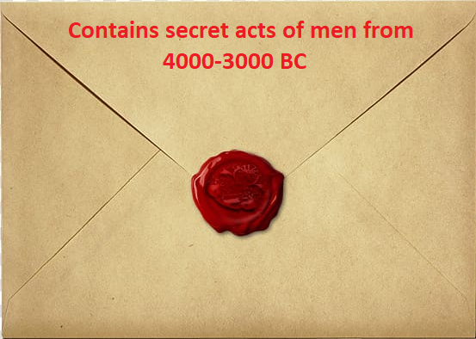…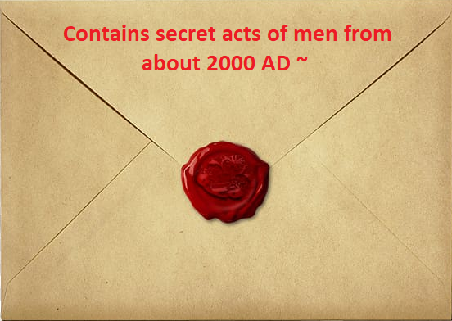
Opened post 33 AD…………………………Opened post 33 AD
The reason why John is shown what is transpiring on earth when the seal is broken, when the envelope is opened, when the journal lock is unlocked etc etc, is because there is no point of reference. That is why we are given it. If it wasn’t for what John was shown directly after, all we would know is that the seals were opened post 33 AD. There would be no way to narrow it down.
So the 7th sealed scroll, the 7th locked book, the 7th sealed envelope does contain in it the acts of men from about the year 2000-on but that does not mean that it was opened at the year 2000.
We are to look at what John is shown as each of the seals from 1-7 is opened and then we are to make a timeline using points of reference from 33 AD on. If what John was shown when the 6th seal was opened has not happened ergo the 7th seal must not and cannot have been opened.
In conclusion and to address the second point, that what John was shown when the seal was opened was events that transpired during those respective years, I’ve already quoted from Joseph Smith clearly declaring that those things which John saw had no allusion to anything previous to John’s time, but here is another quote from Joseph Smith in case you are still doubting:
“The things which John saw had no allusion to the scenes of the days of Adam, Enoch, Abraham, or Jesus…John saw that only which was lying in futurity and which was shortly to come to pass. See Revelation 1:1-3 [This is the] key to the whole subject.” (TPJS, p.289) I would echo the words of our prophet of this dispensation and say the Book of Revelation is one of the plainest books that God ever caused to be written once one applies the “key to the whole subject” which Joseph provided.

